1. Select first 5 rows of the "CustomerName" and "City" columns from the "Customers" table.

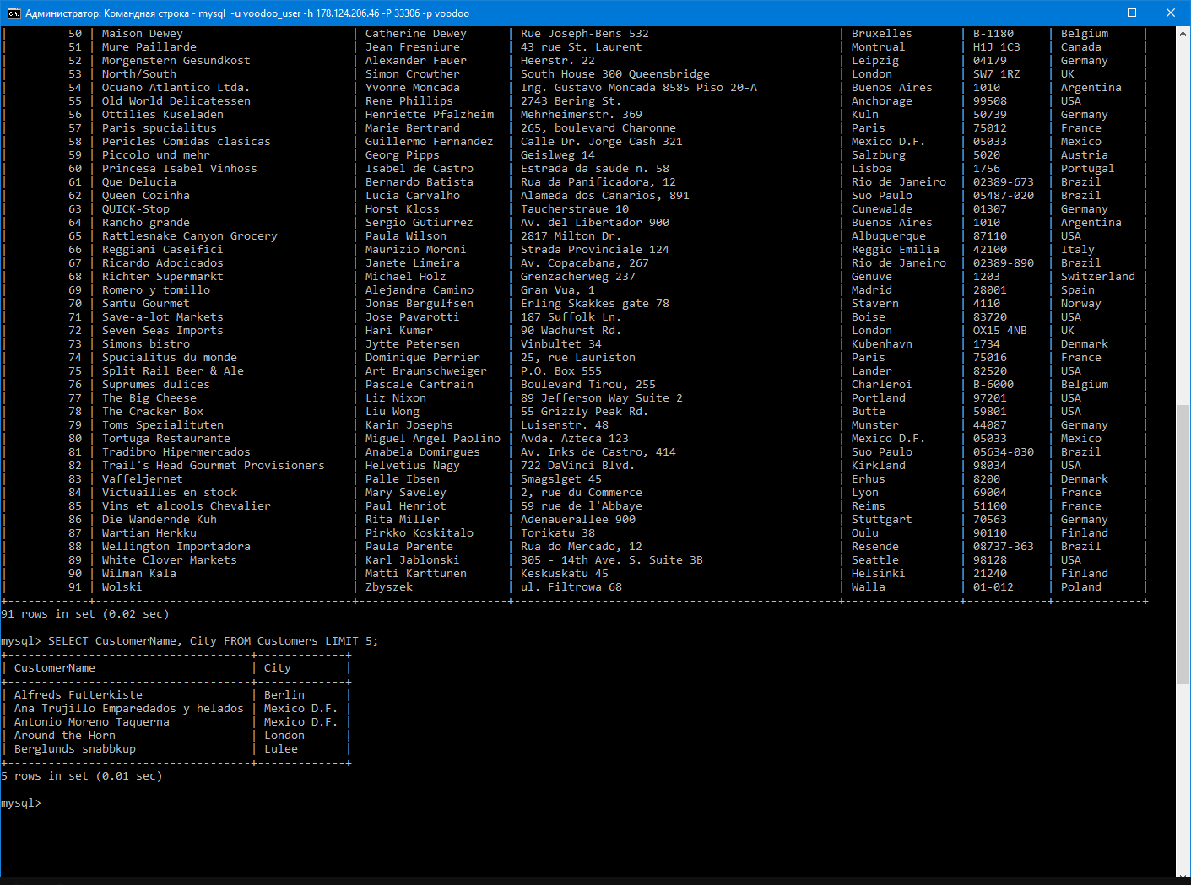

2. Select all the customers (their name and country name) from the country "Mexico".

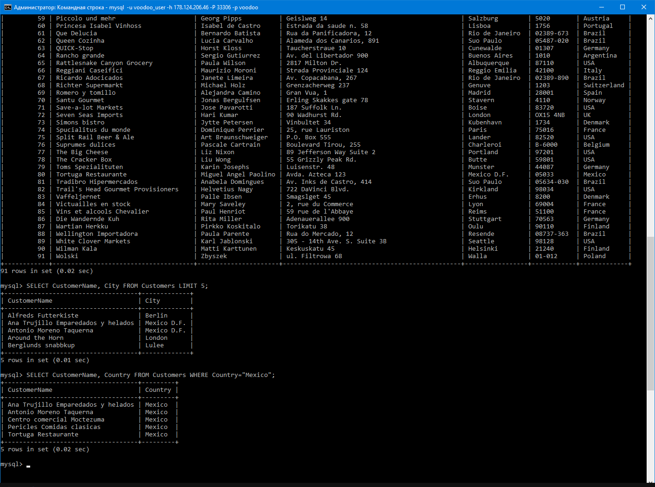

3. Select all customers' records from the country "Germany" and the city "Berlin" or "Mannheim", sort by the Address from A to Z.

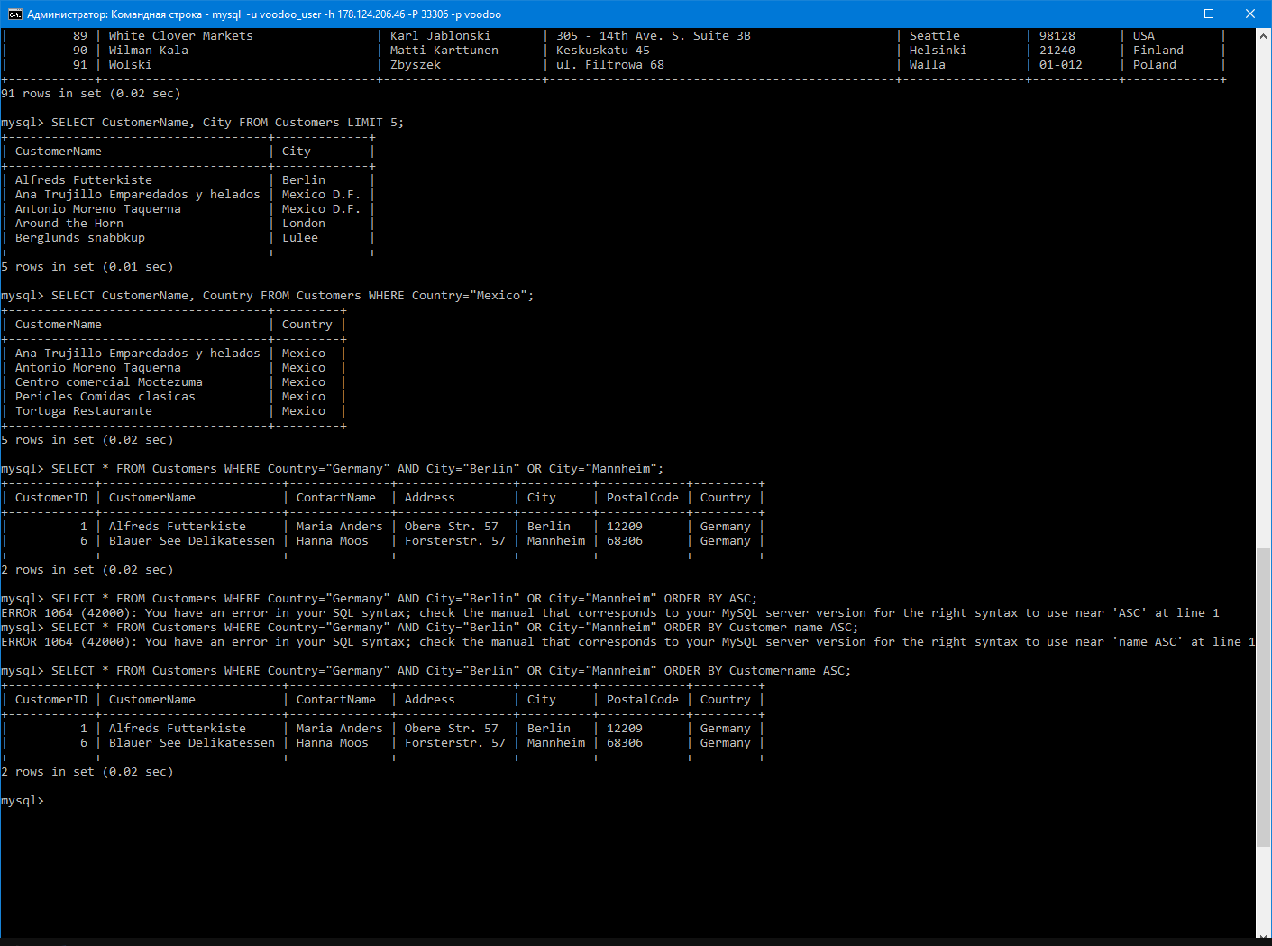

4. Select all customers' records, whose name ends with "s", from country, which name does not contain the pattern "land" and starts with "b", sort by the Country from A to Z.

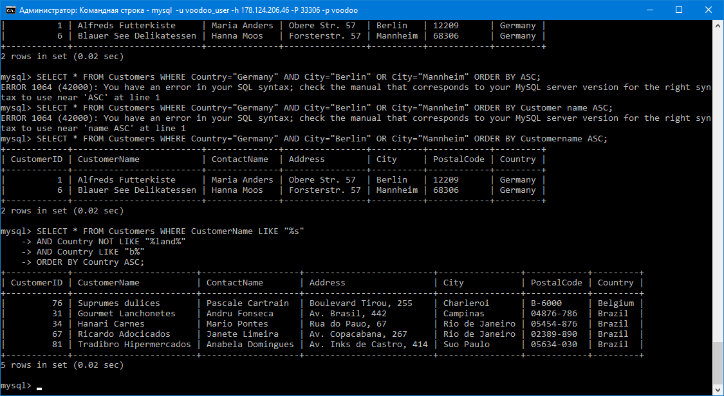

5. Select all customers' records from a City of "Paris", "Berlin", "Mannheim" or "London" and their IDs greater than 10, but less than 20.

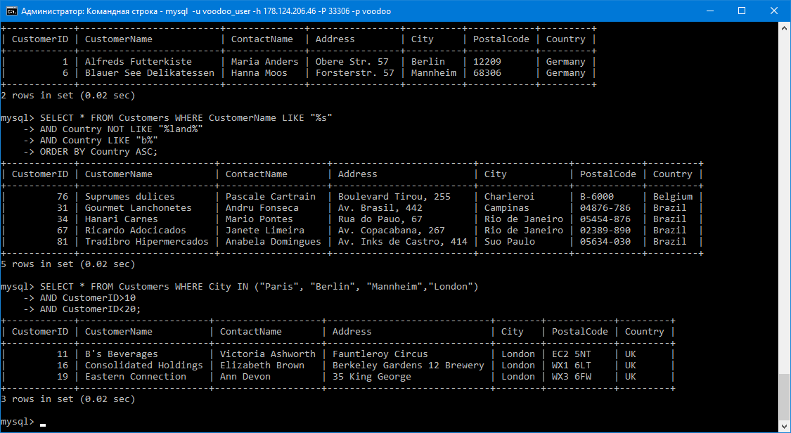

6. Selects all orders with an ordered between 04-July-1996 and 09-July-1996.

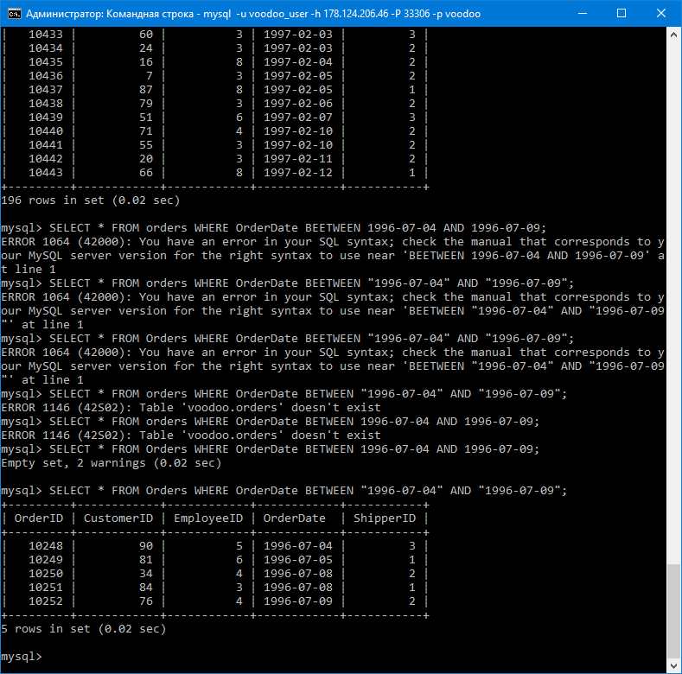

7. Select the list of orders (its ID, customer's Name and the date of an order) which were made in the second decade of February, 1997

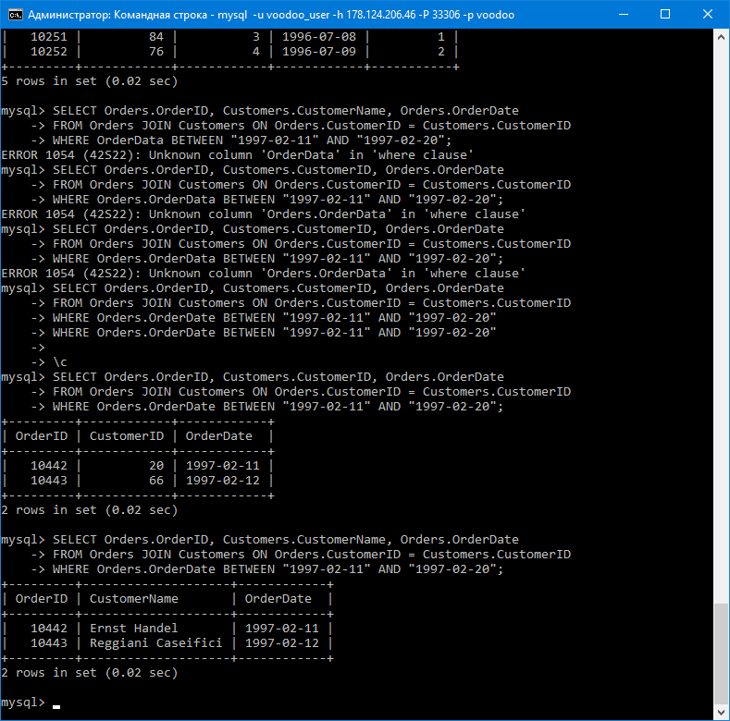

8. Find all employees (their names) and "Amount of orders" they made (if any), sort them by name from A to Z, ensure all result columns have appropriate names.

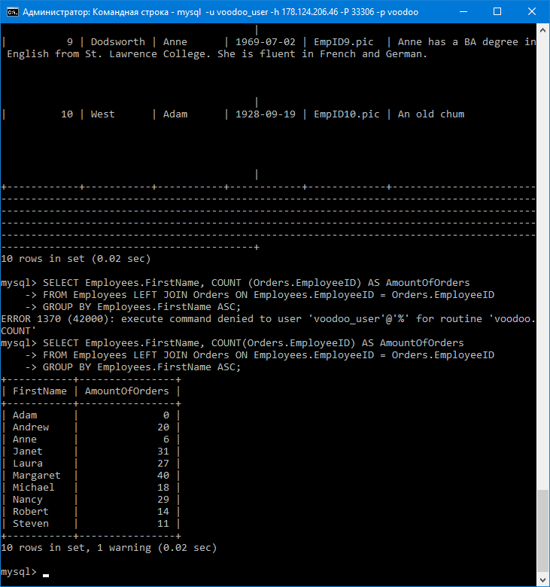

9. Select all unique UK cities, where customers and suppliers live, sort from A to Z.

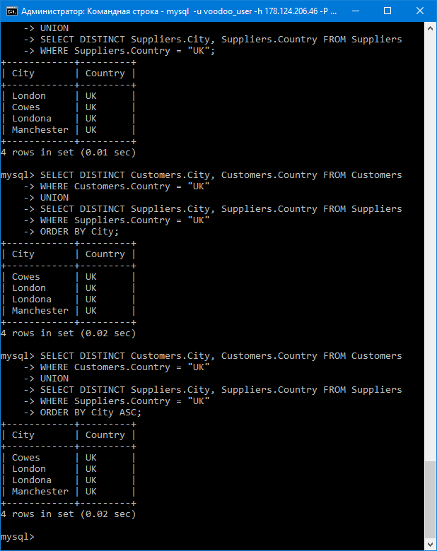

10. Select products (their names) and prices records that have an above average price, but cheaper than 33, sort ascending.

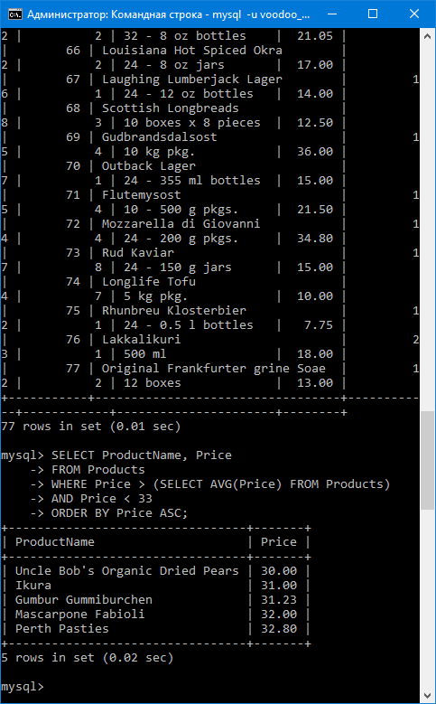

\*\*\*

11. Select shippers that shipped an above average (to column "Sender"), amount of orders they shipped (to column "Items Sent") and percentage of shipping from overall amount (to column "Quota", values have to be with '%' sign)

SELECT DISTINCT Shippers.ShipperName AS Sender, SUM(OrderDetails.Quantity) AS ItemsSent,

CONCAT(FORMAT((SUM(OrderDetails.Quantity) / (SELECT SUM(Quantity) FROM OrderDetails))\*100, 2), “ %”) AS Quota

FROM Shippers JOIN Orders ON Shippers.ShipperID = Orders.ShipperID

JOIN OrderDetails ON Orders.OrderID = OrderDetails.OrderID

GROUP BY Shippers.ShipperName

HAVING SUM(OrderDetails.Quantity) > (SELECT SUM(Quantity) FROM OrderDetails) / (SELECT Count(ShipperName) FROM Shippers);

